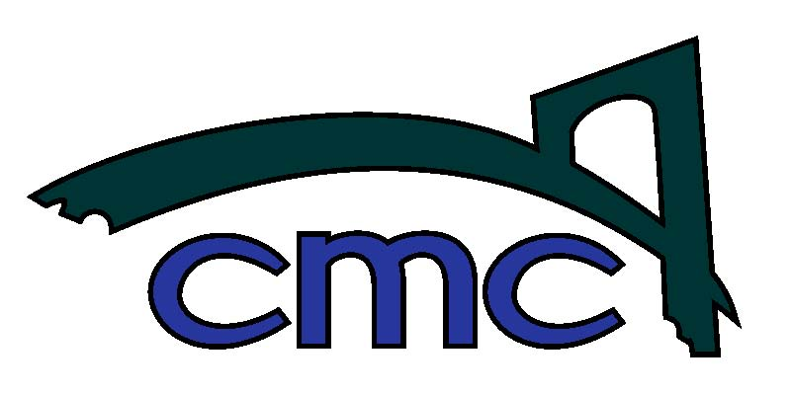

Clackamas Middle College

Phone: 503.518.5925
Fax: 503.518.5928
Clackamas Middle College
12021 SE 82nd Avenue
Happy Valley, Oregon 97086

April 25th, 2016

Dear CMC Juniors, Take 5 Seniors and Parents:
As we near the end of the 2015-2016 school year, we want to make sure all of our Juniors and Take 5 Seniors are prepared for their college planning timeline. We would like to invite all Juniors, Take 5 Seniors and parents to attend a College Planning Night at CMC on Monday, May 2nd from 6 pm to 7 pm.
During this presentation, we will cover the following very essential college planning topics in details:

- College planning timelines
- SAT / ACT registration and test prep
- Financial aid and scholarship updates
Thank you for your time and we look forward to seeing you next Monday.
Sincerely,

Brian Sien, Ed. D.
Principal
Clackamas Middle College

